SIMATS ENGINEERING (SAVEETHA SCHOOL OF ENGINEERING)
Department of Artificial Intelligence and Machine Learning

ASSESSMENT TOOL 1 – Analytical Problem Solving (5 QUESTIONS)

Course Code: | MLA0407 | Course Title: | Deep Learning
CO Assessed: | CO1 | Assessment: | Assessment Tool 3 – Experiments
Weightage: | 35% of CIA | Total Marks: | (5 Questions × 10 Marks)
CO1 Statement: | Apply the fundamental concepts of machine learning and neural networks to design and analyze learning algorithms using perceptrons, multilayer perceptrons, forward propagation, backpropagation, gradient descent optimization techniques, and Maximum Likelihood  Estimation for solving real-world problems.
Student Name: | P. Lohith Krishna | Reg. No.: | 192325122
Section / Batch: | AIML | Date:

Code of Conduct
I P. Lohith Krishna certify that this submission is my original work and that I have adhered to the guidelines specified for this assessment. I understand that any violation of academic integrity rules

will result in disciplinary action. Signature of the Student:

Name: - P. Lohith Krishna Course code: - MLA0407
Reg no: - 192325122 Course Name: - Deep Learning

Experiment 1: Implementation of a Single Artificial Neuron Objective: Implement a single artificial neuron using Python. Task: Total Marks: 50 Annexure A Experiments
Aim
To implement a single artificial neuron using Python that accepts multiple inputs, computes the weighted sum, applies a step activation function, and generates the output.
Algorithm
- Start.
- Define input values.
- Define weights and bias.
- Calculate weighted sum.
- Apply step activation function.
- Display output.
- Stop.
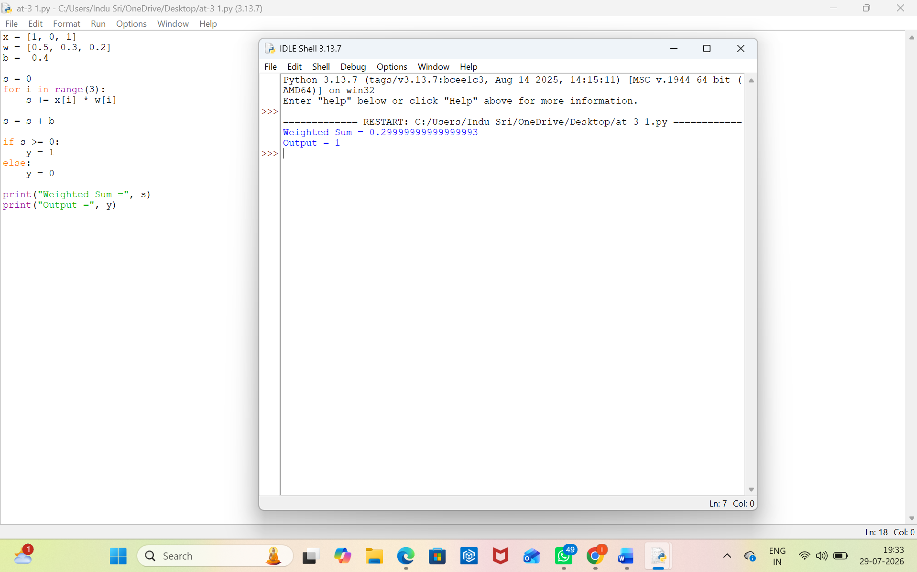

Result: -
The artificial neuron successfully computed the weighted sum and produced the correct binary output using the step activation function.
Experiment 2: Perceptron for AND Gate Objective: Implement the Perceptron Learning Algorithm. Task:
Aim
To implement the Perceptron Learning Algorithm for the AND logic gate.
Algorithm
- Start.
- Define AND gate inputs and outputs.
- Initialize weights and bias.
- Train the perceptron.
- Update weights using the perceptron rule.
- Display final weights and predictions.
- Stop.
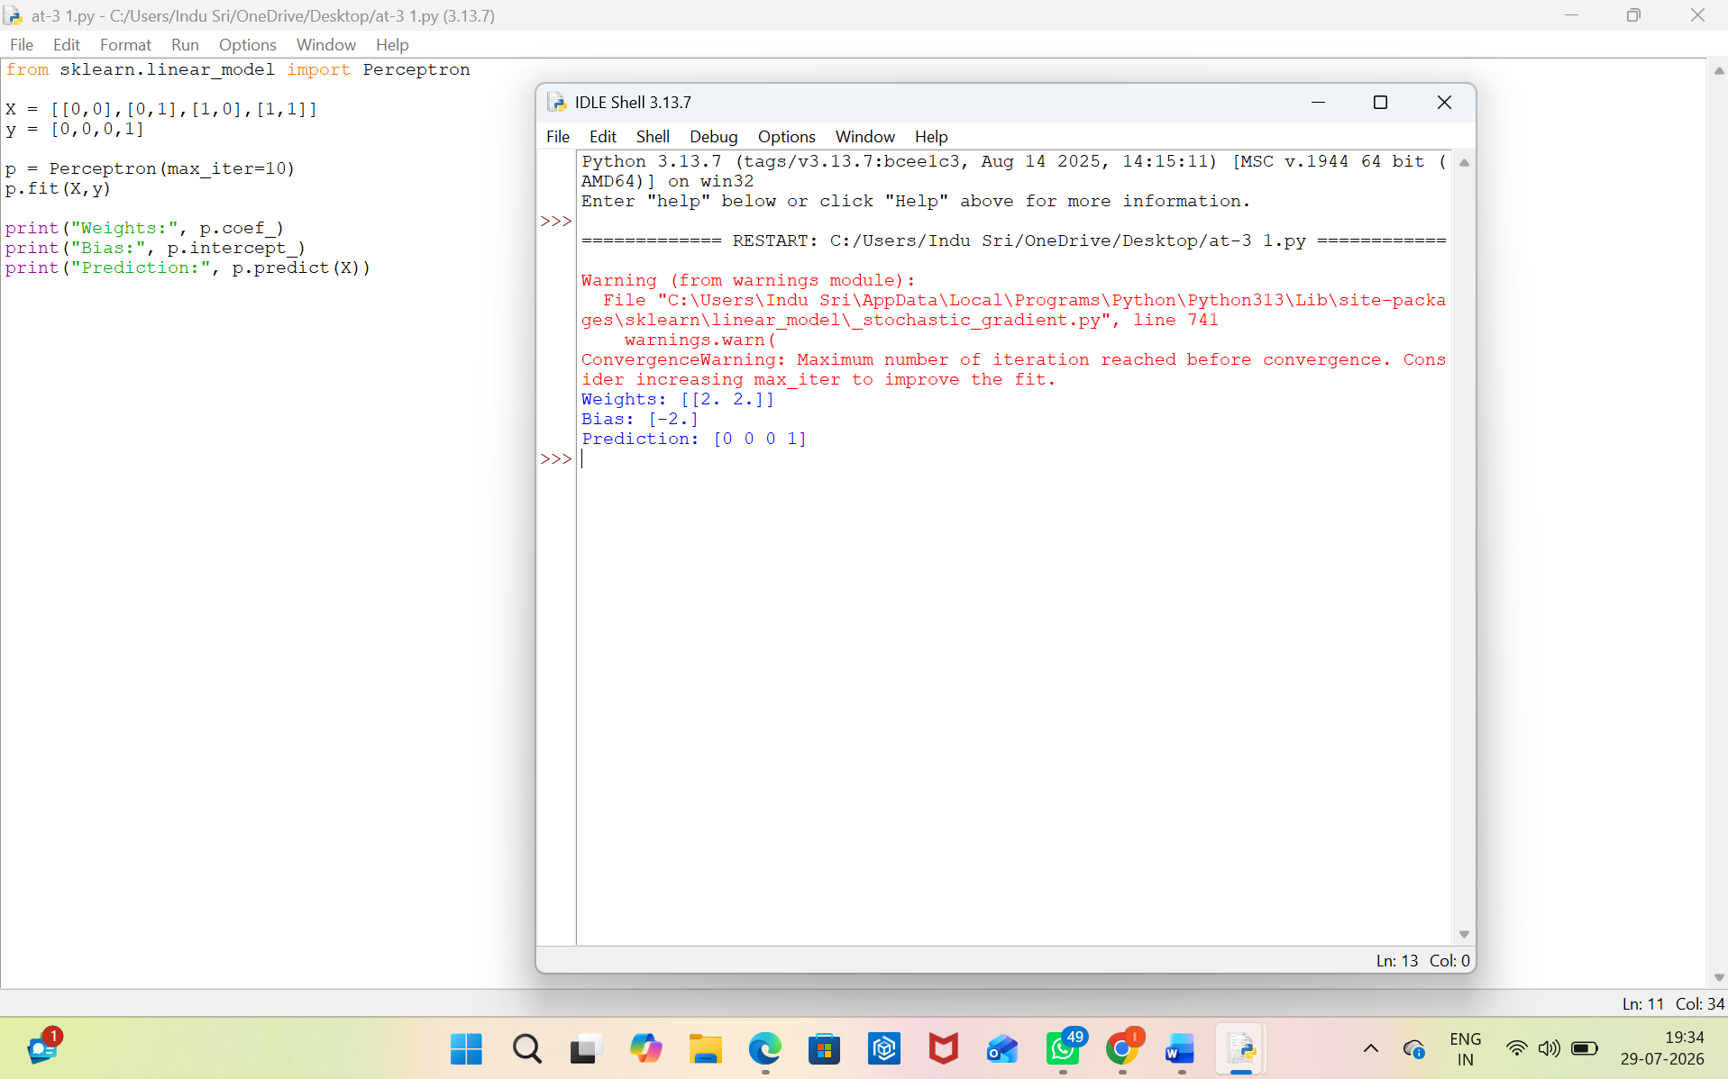

Result: -
The perceptron correctly classified the AND gate with 100% accuracy.

Experiment 3: Perceptron for OR Gate Objective: Design a perceptron model for binary classification. Task: Implement a perceptron to classify the OR logic gate.
Aim
To implement a perceptron model for the OR logic gate.
Algorithm
- Start.
- Define OR gate inputs and outputs.
- Initialize weights and bias.
- Train the perceptron.
- Predict outputs.
- Display weights and predictions.
- Stop.
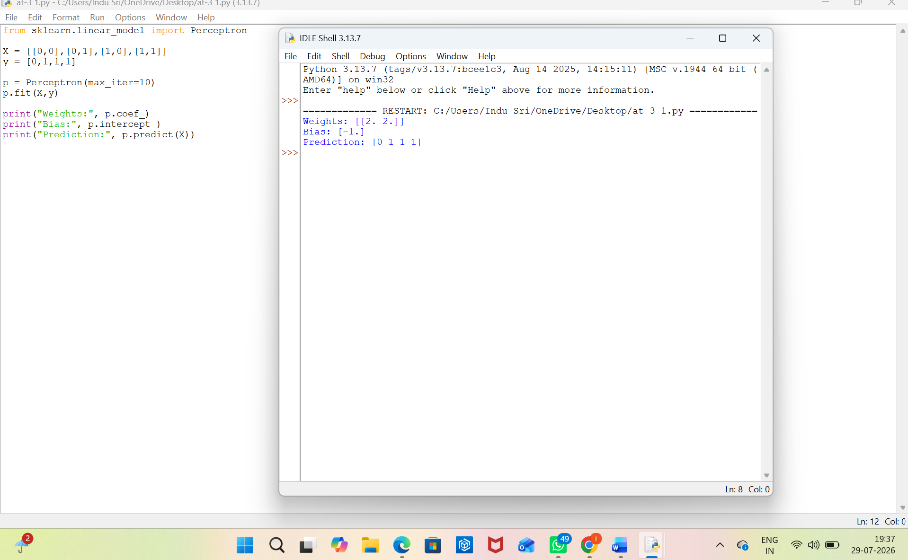

Result: -
The perceptron correctly classified the OR gate with 100% accuracy.
Experiment 4: XOR Classification Analysis Objective: Study the limitations of a single-layer perceptron. Task: Attempt to train a perceptron for the XOR logic gate.
Aim
To study the limitations of a single-layer perceptron using the XOR logic gate.
Algorithm
- Start.
- Define XOR inputs and outputs.
- Train a perceptron.
- Predict outputs.
- Observe incorrect classification.
- Conclude that XOR is not linearly separable.
- Stop.
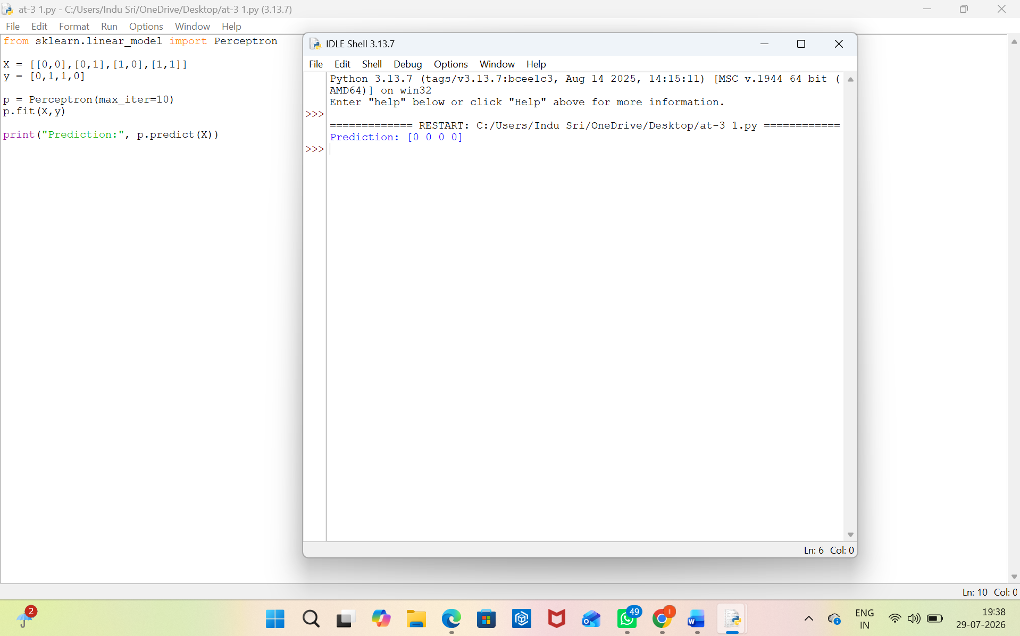

Result: -
The single-layer perceptron failed to classify the XOR gate because it is not linearly separable.

Experiment 5: Gradient Descent Optimization Objective: Understand Gradient Descent. Task: Implement the Gradient Descent algorithm to minimize a simple quadratic cost function.
Aim
To implement the Gradient Descent algorithm for minimizing a quadratic cost function.
Algorithm
- Start.
- Initialize learning rate and parameter.
- Compute gradient.
- Update parameter using Gradient Descent.
- Repeat until convergence.
- Plot cost versus iterations.
- Stop.
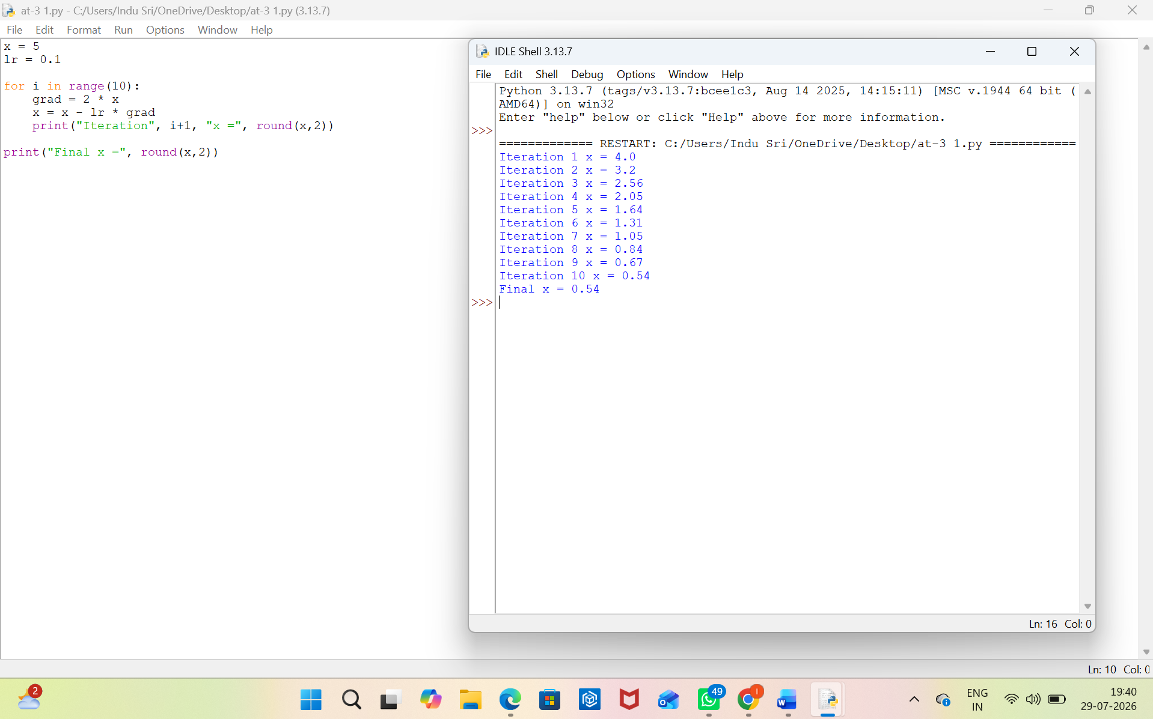

Result: -
Gradient Descent successfully minimized the cost function, showing convergence over the iterations.
Rubrics for Calculation

Criteria | Weightage | Level 4 (Exemplary) | Level 3 (Proficient) | Level 2 (Developing) | Level 1 (Beginning)
Technical Content Accuracy | 30 | Highly accurate, indepth, and insightful technical explanation | Technically correct content with adequate depth and  clarity | Basic concepts presented with limited accuracy and depth | Content contains major technical errors; concepts poorly  understood
Problem  Identification | 25 | Problem rigorously analyzed using appropriate and advanced methods | Problem clearly defined with a logical engineering approach | Problem identified but analysis or methodology is  weak | Problem statement unclear or incorrect; no  logical approach
Use of Tools | 20 | Advanced tools, well-analyzed data, and highly effective visuals | Appropriate tools and data used effectively with clear  visuals | Limited use of tools and basic data interpretation | Minimal or incorrect use of tools and data; poor visuals
Communication | 15 | Highly engaging, confident, and audience-focused delivery | Clear, organized, and professional  communication | Understandable but lacks clarity, structure, or  confidence | Poor organization, unclear speech, ineffective slides
Professionalism | 10 | Exemplary professionalism, leadership, and ethical awareness | Professional conduct with effective team collaboration | Basic professionalism; uneven team participation | Lacks professionalism; minimal contribution or ethical awareness

Faculty In-charge | Course Coordinator | Program Director
Signature: | Signature: | Signature:
Date: | Date: | Date:

